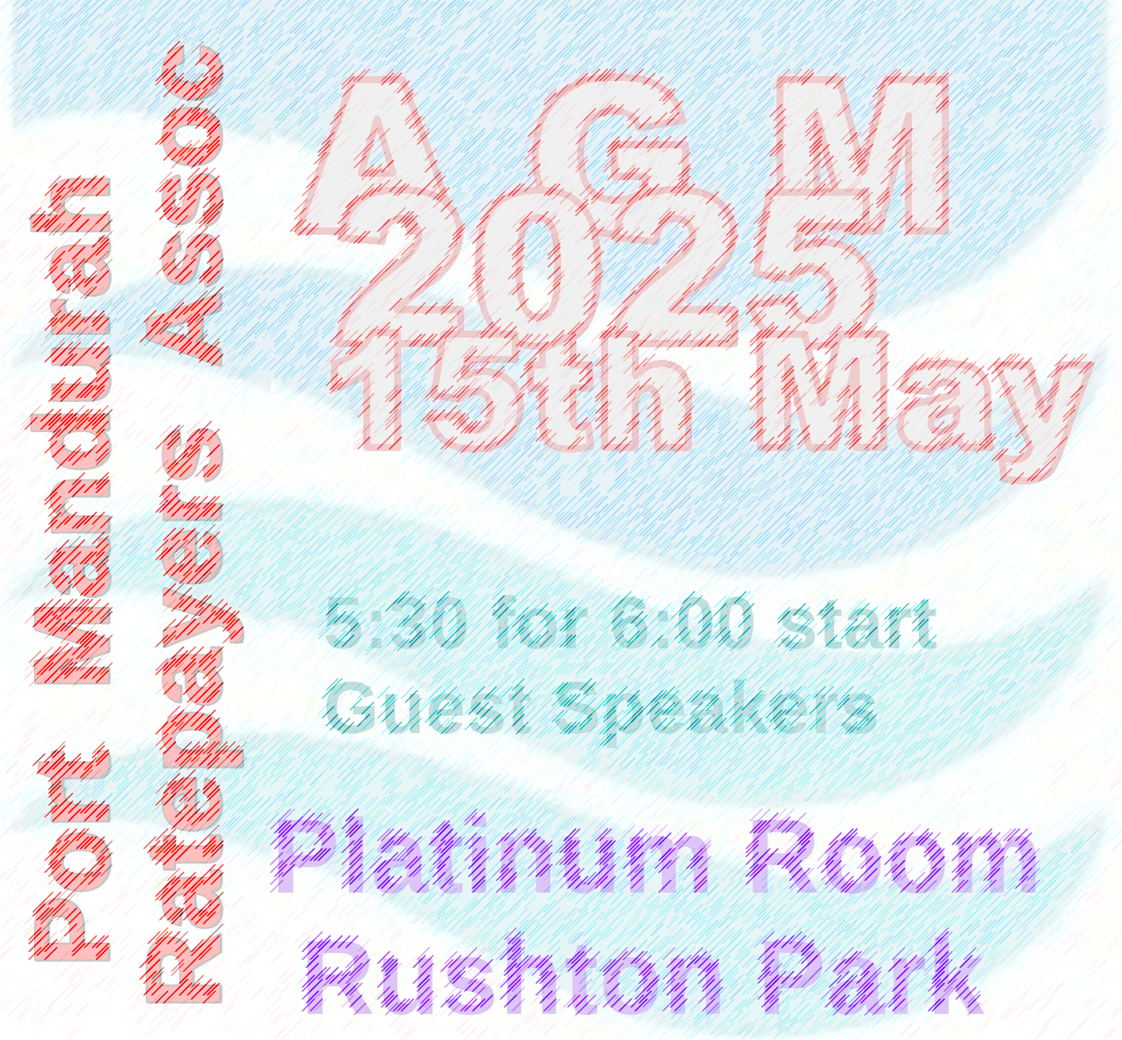
AGENDA for meeting
- President welcomes members, ensures a quorum present and attendance book signed.
- Guest Speaker
- Apologies recorded.
- Minutes of 2024 AGM presented. To be confirmed.
- President’s Report.
- Treasurer’s Report.
- Business arising from 2024 minutes as discussed.
- Election of Committee for 2025/26.
- General Business.
- Close meeting.

Nomination Form for the PMRA 2025/26 Committee

NOMINEE: I, ________________________________________________________________________

of_______________________________________________ confirm that I am a Port Mandurah ratepayer and that I consent to my nomination for the PMRA Committee.

Signed: ____________________________________________________ Date: 15th May 2025

NOMINATOR: I, _________________________________________________________________________

of______________________________________________ confirm that I am a Port Mandurah ratepayer and that I nominate the above named for the PMRA Committee.

Signed: ___________________________________________________ Date: 15th May 2025

SECONDER: I, _______________________________________________________________________

of______________________________________________ confirm that I am a Port Mandurah ratepayer and that I second this nomination for the PMRA Committee.

Signed: _____________________________________________________ Date: 15th May 2025
Please fill in the form above if you would like to nominate yourself or someone else to the committee.
Hand the form to the President or Secretary at the meeting
. If fewer than ten written nominations are received, then nominations will also be invited from the floor.

